**APPL IN SEQ MATH NAME___________________________**

**HOMEWORK**

**C:\Documents and Settings\cburns\Local Settings\Temporary Internet Files\Content.IE5\HXML5HS9\MC900044986[1].wmf**

**SCHOOL DANCE**

The senior class is sponsoring a dance. The cost of a student DJ is $160. Tickets are $7.00 each.

1. Write a linear equation representing the number of tickets sold (x) and the profit (y) from the dance. Y=_______________________ (3 points)

1. Determine how many tickets need to be sold to break even. ( 3 points)
2. On the accompanying grid, graph and label the equation from above. (4 points)

To plot the points, it might be helpful to make a table of values.

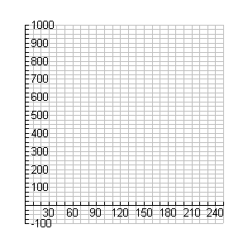

1. From your graph and/or equation, determine the profit if the class sells 50 tickets. (2 points)