CURRICULUM OUTLINE 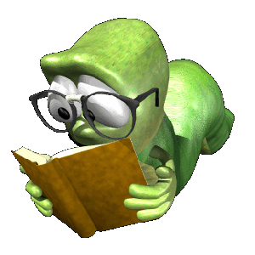
The course is a full year course but may be used by some students for a half credit. This is dependant upon your credit needs.

Each year I try to incorporate the following:
- 1-2 short stories
- 1-2 novels
- 1 play
- A poetry unit
This is dependent upon the time allowed during each quarter and the pace/cooperation of the students.
Books We Will be Reading:
- Short Story - "The Most Dangerous Game
- Novel - The Wonderful Wizard of Oz
- Play - "A Raisin in the Sun"
- Poetry - Undetermined at this time
- Novel - Alice's Adventures in Wonderland

For each one of these stories we will be concentrating on a particular theme and different literary devices that the author may use to enhance the writing.

Examples of Literary devices would include but not be limited to:
- Alliteration
- Assonance
- Characterization
- Hyperbole
- Imagery
- Metaphor
- Onomatopoeia
- Personification
- Simile

